# JACARANDA TRUST

Newsletter NO. 3

SEPTEMBER 2017

# THE MICHAEL PROJECT

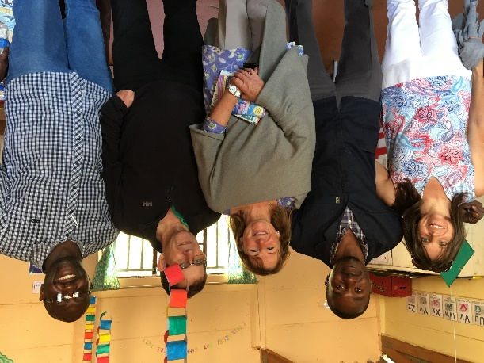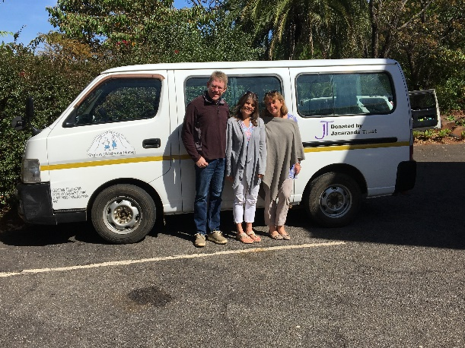

A ministry of Greystone Park Church and headed up by Dave and Helen Hobbs, has been working with orphans in its pre-schools, prison creche and Shalom Children’s home for 17 years. Greystone Park Church has now amalgamated with the River of Life Church that has its roots in Kent, England. It is a much larger church with more resources in people, skills and funds to support the Michael Project. The project is in the process of a transition of leadership as Dave and Helen Hobbs take up a more ambassadorial role. Simba and Barbara Pfupajena now head the management team. Simba and Barbara are adoptive parents themselves and come from internal auditing and administrative backgrounds respectively. Rephat Nyarenda, a pastor is a key part of the management team having joined the Michael Project in 2006. He and his wife Mavis have been foster parents which they continue to do today.

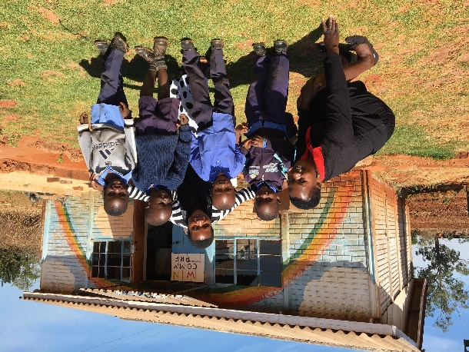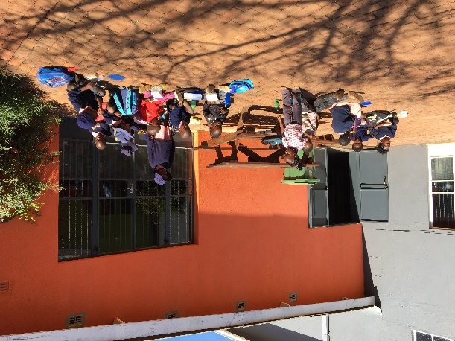

## Greystone Park Pre-School

It was great to spend the day with Helen, Dave, Rephat and Simba of the Michael Project visiting their 4 projects. We travelled in the bus donated by Jacaranda Trust, ably driven by Rephat especially over the potholes!! We met at the River of Life Church in Greystone Park, the church buildings and facilities are lovingly cared for. The existing pre-school is a fairly small room attached to the church. I met dedicated teachers Siara and Melody and happy children attending a holiday club at the pre-school.

There is a high demand for places at the pre-school and Jacaranda Trust is excited to be the main donor for the construction of a new permanent purpose built building that will educate 40 pre-school children on a site close by to the existing classroom and in the grounds of the church.

The plans for this building include toilets, a store room and a covered verandah.

The building will cost $50,000 US, JT has donated £10,000 so far and is looking to raise a further £11,000 – the remaining amount will be donated by the church finance team and a Rotary club.

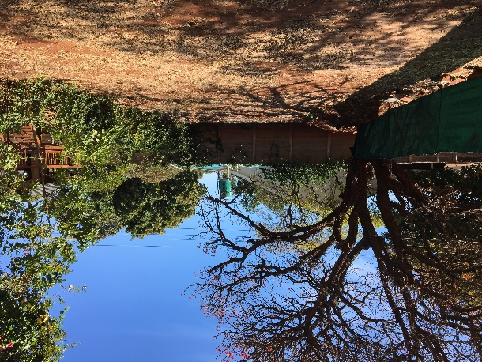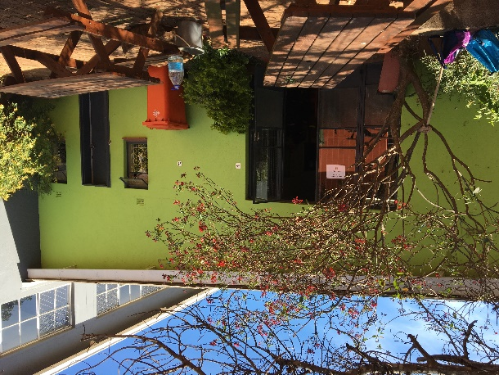

## Creche and Pre-School, Chikurubi Women’s Prison

This life-line was started by Helen and Dave Hobbs 14 years ago. A small building in the grounds of the women’s prison, it offers day care for the babies, toddlers and children of the women prisoners. The babies come from 10months-3 years and are looked after in the creche, they are given breakfast and lunch (7.30am-4.30pm), and are lovingly cared for. At 3 they can join the pre-school and will stay there until they graduate, aged 6 years, to a local primary school and at this point, it is hoped that Social Services can find them a foster family, or they can return to the outside world with their mothers when they are released from prison.

This is a remarkable project giving the children care, food, and pre-school education. Before the creche existed, the babies and children didn’t have access to the outside world at all and lived in the prison with their mothers. This wonderful facility is now offered to the children of the prison guards as well who attend the pre-school along with the prisoner’s children and as children do, they all get along happily and learn together. This has helped build relationships between the mothers and the guards and the prison authorities and the Michael Project, all very helpful and positive.

I met Tinashe who is the Shona male teacher at the pre-school. He is a wonderful, dedicated teacher. Under his guidance, teaching and leadership, the pre-school offers an excellent start for the children. He is incredibly dedicated and is a kindly father figure to the children who are only ever with their mothers and women prison guards.

Very sadly, Sheila who helped Tinashe and was a very dedicated teacher died last year and it was obvious to me that Tinashe could really do with more permanent support. A teacher costs about $US400 per month (this includes costs of transport). It would be wonderful if JT could help with this.

Following a recent campaign LOVE LIVES HERE about Orphan Care and How to get Involved at the River of Life Church for the Michael Project, volunteers have offered their services to give Tinashe support in the pre-school which is good news.

A new cabin has been added to the building and this is a quiet space for Tinashe to teach children, away from the noise of babies and toddlers. There is also an outdoor kitchen area for cooking and JT via a kind donor, is donating a gas cooker here. This will relieve Tinashe the job of chopping firewood for cooking.

Pastor Rephat and Simba hold 2 weekly meetings for the women prisoners, where they can be ministered to and offered help and guidance especially prior to leaving the prison. Quite often these women are rejected by their families, Rephat tries to put them in touch with a local church in the area they move to. They are also given a support pack of basic essentials when they leave. Rephat was pleased to have the Bible Alive magazines I brought and would like me to send more.

### Shalom

A heart warming visit to Shalom, a beautiful home in the suburbs of Harare which is the Michael Project home for orphans. The children are looked after in family groups, headed by Teclar and Portia, Sharon, Susan and Spyea, Rephat and Mavis. They are educated at the local primary school, prior to this attend the pre-schools either at Greystone Park or Wingate.

Very sadly there are a staggering 1.6million orphans in a population of 16 million in Zimbabwe.

The Michael Project’s programme of adoption through the network of churches in Zimbabwe is gaining momentum. Simba and Barbara Pfupajena have exciting plans and a clear vision for this adoption project along with Dave and Helen and others at The River of Life Church.

They also have exciting plans for Shalom, where they plan to convert a building in the garden to care for abandoned babies until foster homes can be found. Tragically 30-40 babies are found abandoned each month in Harare at present.

Jacaranda Trust has supported Shalom by providing solar water heaters for the families and recently a very kind donor provided a much needed 4x4 truck to transport the children and goods.

I was heartened to see the children at Shalom, they all looked so happy and well cared for. It was great to see Luke and Josiah, two children who have special needs are doing really well. JT has helped with school fees at a special school Silver Linings, for these two boys and getting one on one teaching has really made a difference and helped them to progress.

### Wingate Pre-School

### 

### I met dedicated teachers Letwina and Esther at the Michael Project’s Wingate Pre-School. They do the most amazing work with 3-6 year olds giving them a wonderful start to primary education. Teaching up to 40 children, these teachers give hope and a future in education to many kids in a very poor area of Harare. The classroom is very colourful, lots of lovely paintings, posters, charts on the walls and the teachers record keeping and preparation plans looked incredible.

Simba and Barbara have plans to renovate a building next to the pre-school possibly to house a pop-up classroom for possibly older children to attend school.

Jacaranda Trust donated cash $1300 US towards paying special school fees for one of the disabled children in Shalom.

#### RESCU HOSTEL AND WORKSHOP

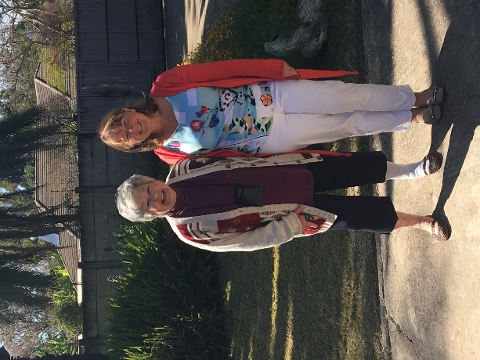 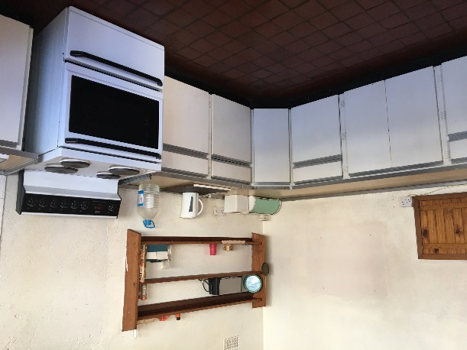

JT is fortunate to liaise with Rodger and Margy Giles, a couple based in Harare who help and look after the finances of the RESCU hostel. Unfortunately Rodger had recently fallen and broken his femur and Margy very kindly drove me to the hostel and introduced me to Hettie.

Robin Bottomley is our liaison with all things to do with the RESCU workshop and he kindly took me on a tour of the workshop in the afternoon.

**Hostel –** Hettie is an incredibly devoted carer and housekeeper at the RESCU hostel in Harare, a loving and safe home for 11 disabled men. Jacaranda Trust has provided for redecoration of the hostel over the years, new guttering and facia boards, carpeting, a new cooker and general support when needed. It was good to see what has been done and also what needs doing! The wall surrounding the property urgently needs repairing for security and the house needs new carpets. JT has donated some money towards the wall repairs and hopes to fund the rest. Some of the men work at the RESCU workshop but others have little to occupy themselves.

Jacaranda Trust donated cash US $650 to put towards repairing the wall.

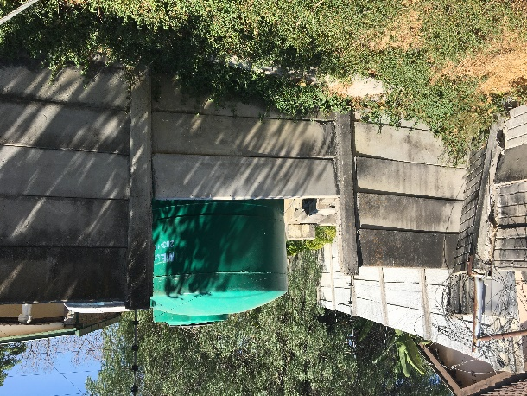 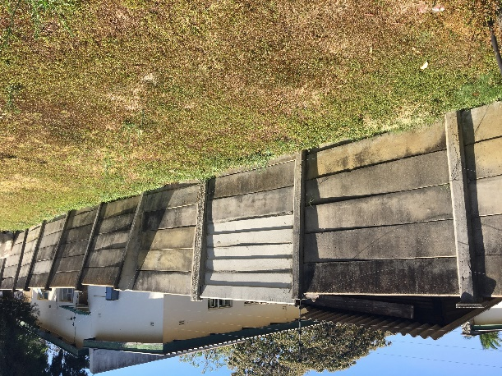

**Rescu Workshop**

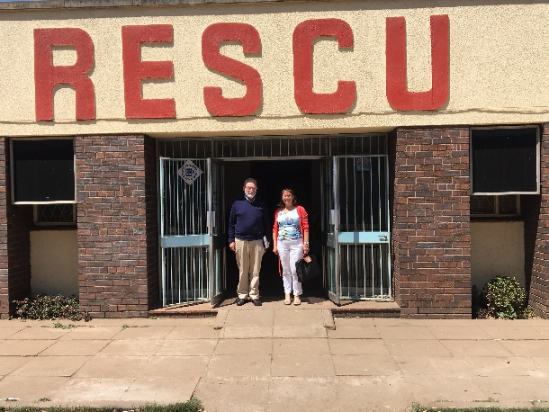 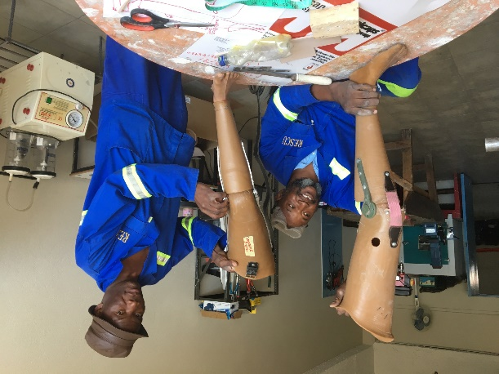

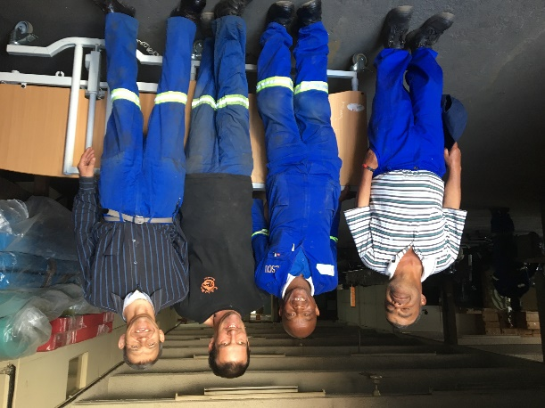

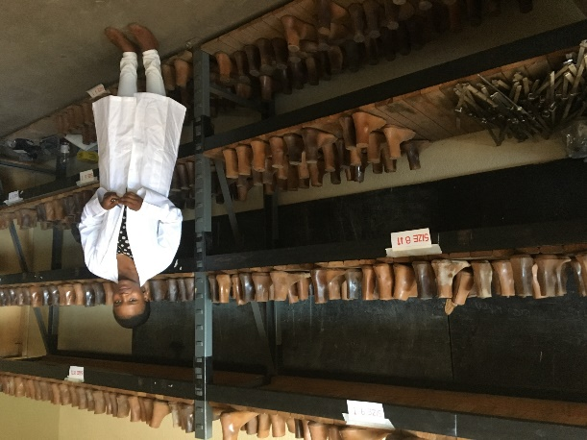

It was an inspiring and emotional visit to the RESCU workshop to see where and how the Jaipur Limb is being made. Emotional as it is heart rending to meet disabled people who are so thankful for the opportunity to work, also my dear brother Robert worked at RESCU when it was first set up, by a group of parents, including our parents in the late 1970’s.

Meeting Misi, the technician and his helper Cephas in the workshop was very inspiring. Misi is in a wheelchair and is very capable. He and Cephas are trained in the assessment and fitting of the Jaipur Limb for recipients. Misi explained the process in detail with the equipment which is very impressive and is all carried out in the workshop. A Jaipur limb can be made in 2 days. Recently a young boy lost an arm due to cancer and Misi has invented a prosthetic arm, made out of available materials. He is truly amazing. The workshop has all the equipment for assembling the limbs now, funded by Jacaranda Trust, along with Rotary.

Recipients are poor and $500US for a limb is impossible for most people to find. The workshop is actively looking for sponsors of limbs and JT would like to raise funds for this too.

Funds are managed by Robin Bottomley and the workshop is ably managed by Fungai, who is the overall administrator and the stores looked after by Chichi.

The Rescu Workshop is in the process of amalgamating with St. John’s. This should be a symbiotic relationship where St. John’s provide the physio side of helping people with disability and RESCU provide the technical aids. Access to people in the rural areas will be made available via St. John’s network as they have centres in these areas. Robin says 150 limbs a year need to be provided to break even and would like to see 300 being produced a year.

Current work at the workshop is assembling wheelchairs for two Rotary/St.John’s projects. Assembling /repairing other donated medical equipment for St. John’s. Wheelchair repairs for people and for the Jairos Jiri organisation. Rescu has also been going out to assess people needing wheelchairs. The shoe making projects is on hold because of other work but they plan to re-start it.

Jacaranda Trust donated cash $US 650 to pay for one recipient to receive a full Jaipur limb, with cash put towards funding another.

**SHINGIRIRAI TRUST**

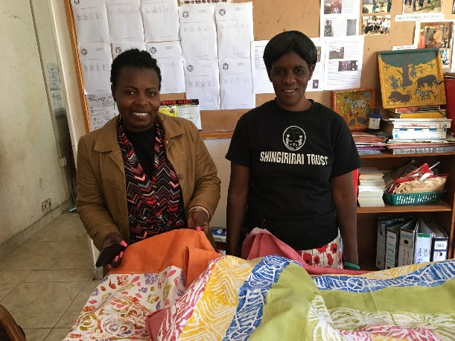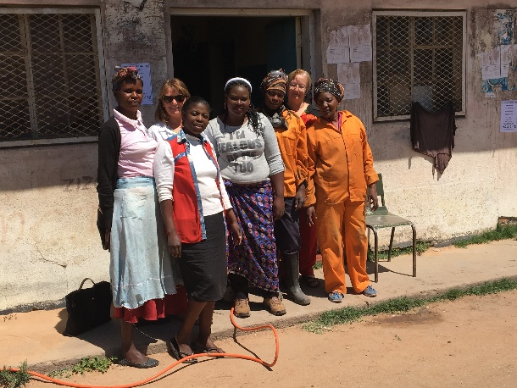

Joy Peacocke, Trustee took Annie on a tour of the projects Shingirirai Trust support. It was a very heartening and inspiring day. Firstly we visited the GLASS4AFRICA project that is a glass re-cycling project in Mbvuku Township. I met Tiny and her team of women, they produce great products, vases, perfume bottles, wine and tumbler glasses, mobiles, etched bowls, all from recycled bottles. It is very challenging for the women to find a market in the current economic situation. I found this hard not to be able to help and bought as much as I could fit in my suitcase!!

We then drove to Tafara, a nearby township where the Shingirirai office and school club is based. I met Stella and Laura, Stella is an administrator and Laura works in the office along with Virginia.

Laura and Virginia make beautiful hand-made potato print tablecloths, cushion covers, wraps. It was great to connect and see how Jacaranda Trust has helped this incredible charity that empowers women creating income generating projects and providing early years education for children in very poor, high density areas. The well outside the offices has been provided by JT - a life saver as there is no municipal water here.

We visited the Mighty Angels pre-school in Mbvuku. It was lovely to meet the three dedicated teachers, Loice, Thandiwe and Linda and the wonderful children mostly 3-6 year olds, who so appreciate being in school. They are given 2 free school meals here a day, a lifeline for these children who are sometimes hungry on a Monday morning. Many orphans live in extended families. Water is a problem here, there is a water tank (the ground is rocky and not suitable for a well). It costs $60 every 3 months to fill the water tank, always money that needs to be found. JT helped with the refurbishment of the toilet in the pre-school and will provide funds for water for a year.

The children are delightful, so sweet and they sang three songs, including the National Anthem – they stood up very straight for this! I shared photos of lions and elephants with them from my phone which they so enjoyed and also got quite excited..to calm them down, the teacher asked them all to have a little rest, see pic below, this took me back to my primary school days, we often did this after break when we were all hot and bothered! I found this visit very emotional as these children have so little, their teachers are so dedicated and the children love being in school.

On this visit, Jacaranda Trust donated US $1300 cash to help pay rents for the Pre-schools.

